CASE STUDY

Study on an existing working module of Microwave oven.

* A microwave oven (commonly referred to as a microwave)

is an electric oven that heats and cook food by exposing it to electromagnetic

radiation in the microwave frequency

range.

* This induces polar molecules in the food to rotate

and produce thermal energy in a process known as

dielectric heating.

* Microwave ovens heat foods quickly and

efficiently because excitation is fairly uniform in the outer

25–38 mm (1–1.5 inches) of a homogeneous, high water content food item.

Block diagram 1

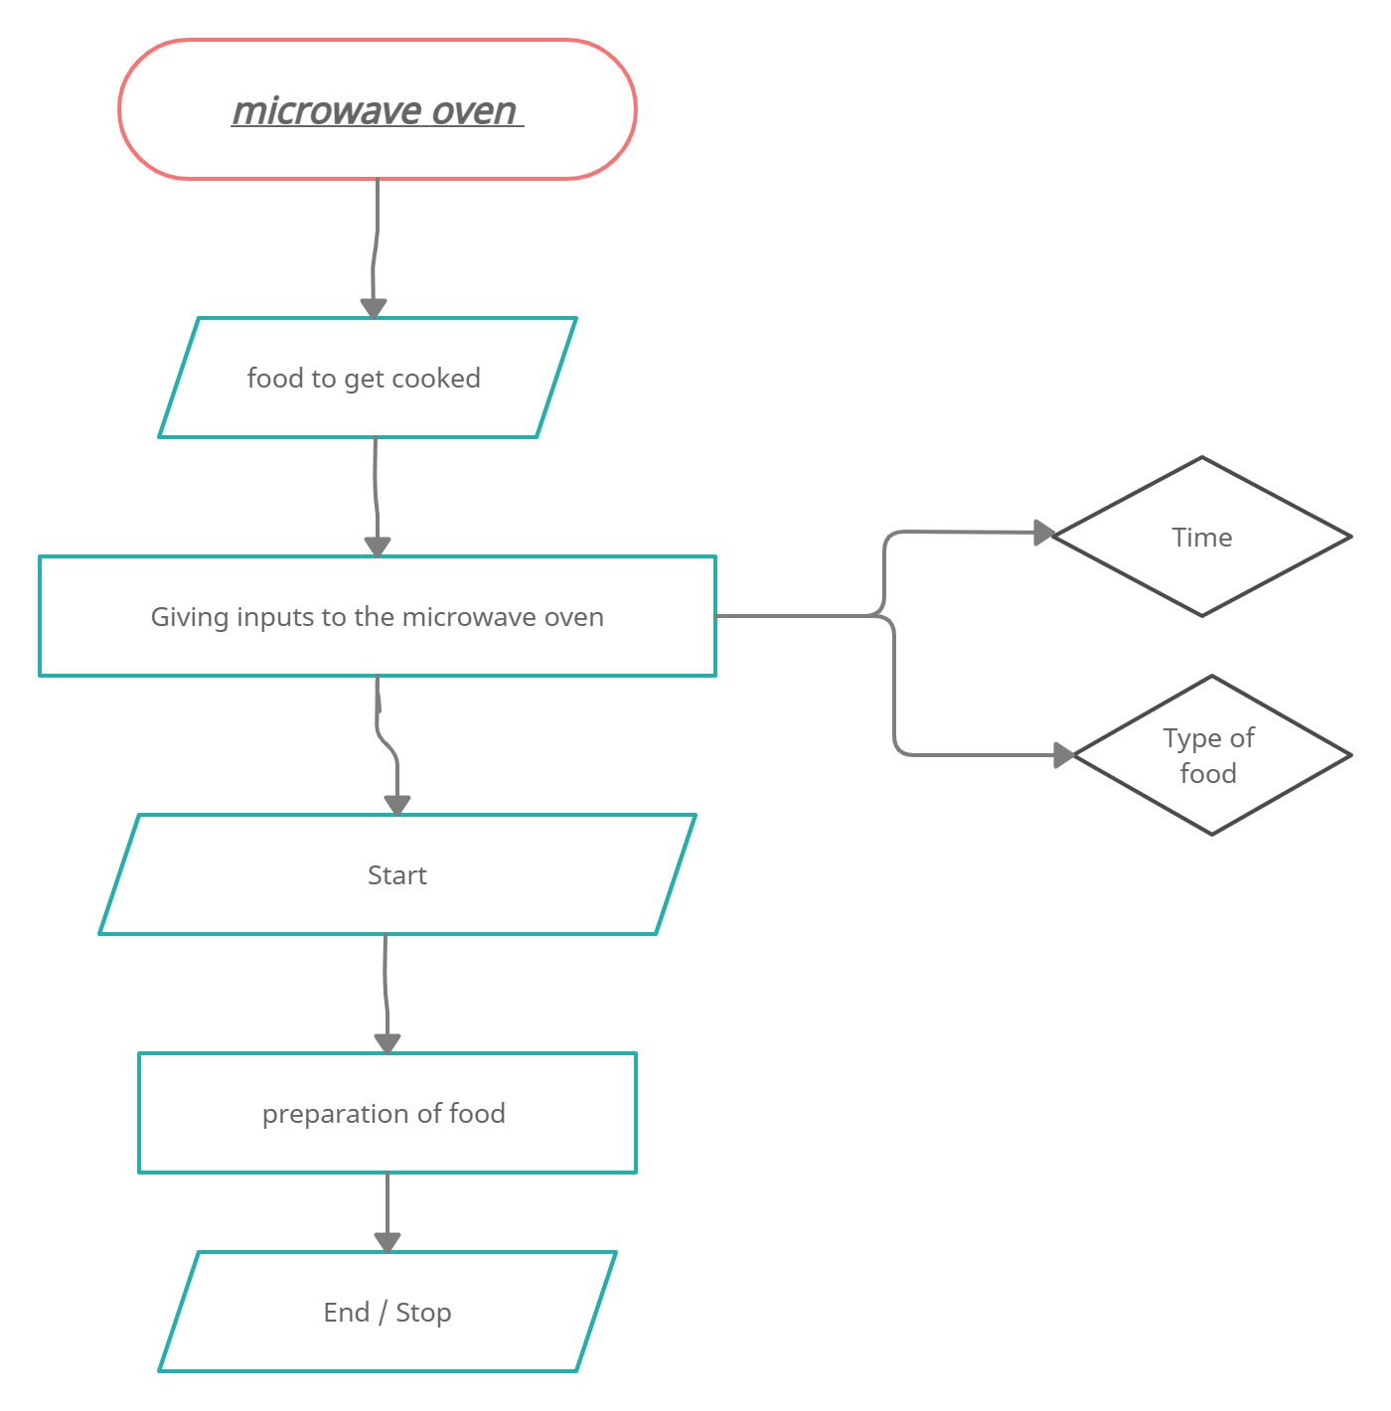

Block diagram 2

